Result:

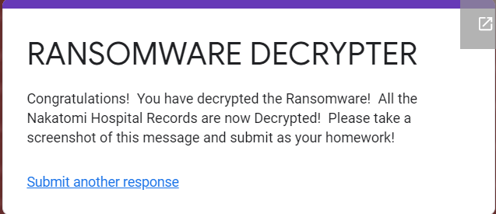

**Riddle 1-6 detail provided below.**

**Riddle 1**

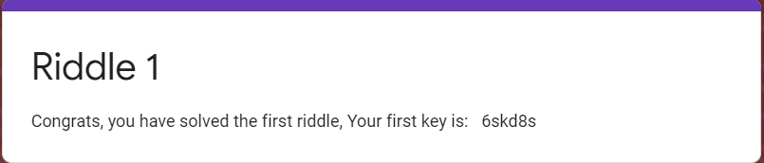

**Key =** 6skd8s

**Riddle 2**

Converted the binary into text. Text = **Gennero.** Enter this into online Riddle 2 will yield (below).

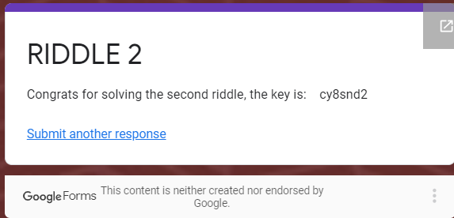

**Key = cy8snd2**

**Riddle 3**

sysadmin@UbuntuDesktop:~$ echo "4qMOIvwEGXzvkMvRE2bNbg==" > cipher_message

sysadmin@UbuntuDesktop:~$ ls -l

total 120

drwxr-xr-x 6 sysadmin sysadmin 4096 Jun 6 10:30 backups

-rw-r--r-- 1 sysadmin sysadmin 25 Jul 10 13:42 cipher_message

sysadmin@UbuntuDesktop:~$ cat cipher_message

4qMOIvwEGXzvkMvRE2bNbg==

sysadmin@UbuntuDesktop:~$ openssl enc -pbkdf2 -nosalt -aes-256-cbc -in cipher_message -d -base64 -K 5284A3B154D99487D9D8D8508461A478C7BEB67081A64AD9A15147906E8E8564 -iv 1907C5E255F7FC9A6B47B0E789847AED

**takagi**

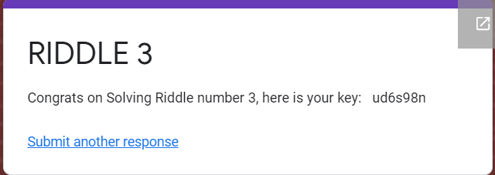

**Key = ud6s98n**

**Riddle 4**

When using Asymmetric key, the sender always uses public key of receiver to encrypt the data and receiver always use private key to decrypt the data.

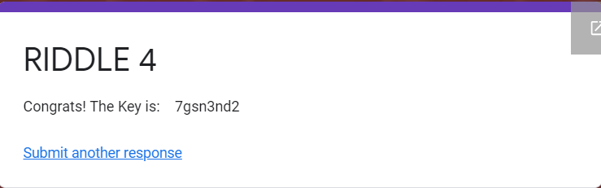

**Key = 7gsn3nd2**

**Riddle 5**

sysadmin@UbuntuDesktop:~$ echo "3b75cdd826a16f5bba0076690f644dc7" > riddle5_hash.txt

sysadmin@UbuntuDesktop:~$ cat riddle5_hash.txt

3b75cdd826a16f5bba0076690f644dc7

sysadmin@UbuntuDesktop:~$ hashcat -m 0 -a 0 -o r5solved.txt riddle5_hash.txt /usr/share/wordlists/rockyou.txt --force

hashcat (v4.0.1) starting...

OpenCL Platform #1: The pocl project

====================================

* Device #1: pthread-Intel(R) Core(TM) i7-1065G7 CPU @ 1.30GHz, 1024/2956 MB allocatable, 2MCU

<pre><font color="#8AE234"><b>sysadmin@UbuntuDesktop</b></font>:<font color="#729FCF"><b>~</b></font>$ cat r5solved.txt

3b75cdd826a16f5bba0076690f644dc7:**argyle**

</pre>

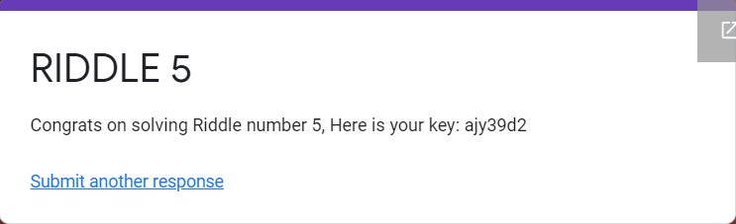

**Key = ajy39d2**

**Riddle 6**

sysadmin@UbuntuDesktop:~$ steghide extract -sf mary-lamb.jpg

Enter passphrase: **ABC**

wrote extracted data to "code_is_inside_this_file.txt".

sysadmin@UbuntuDesktop:~$ cat code_is_inside_this_file.txt

**mcclane**

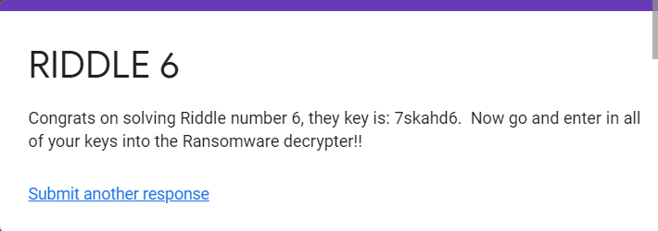

**Key = 7skahd6**

**Decrypter**

